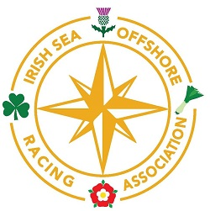

RHYBUDD O RAS - - NOTICE OF RACE
& Entry Form

ISORA P2P
(Pwllheli to Pwllheli)
Coastal Day Race

Racing For IRC and National Handicap for Cruisers NHC.

Date | Number of Races | Warning Signal
Saturday 23rd April 2016 | One long Bay Race | 1155hrs

The Pwllheli to Pwllheli CHPSC and ISORA P2P will be a long bay race and the course will be announced by the Race Officer.
CHPSC Bridge Start.
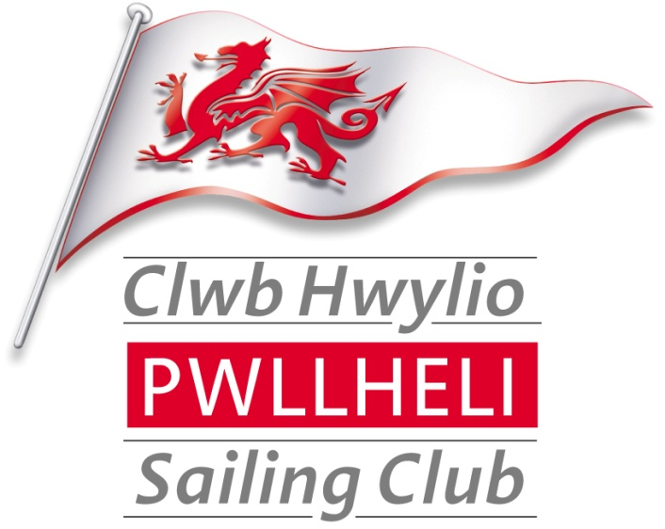
Notice of Race, Entry Form and Race Pack
All available on http://www.pwllhelisailingclub.co.uk/
(See CHPSC Race Pack for Sailing Instructions, Courses and Chart).
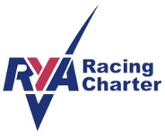
This is an Open Event - all competitors and their crews (guests) will become temporary members of CHPSC for the duration of the event. (Subject to 3.5 below)
On Line Results by Sailwave

ISORA P2P 2015

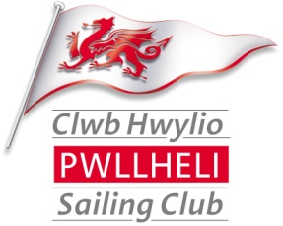
Notice of Race & Entry Form
Organisation.
  - The 2016 CHPSC and ISORA P2P is organised by Clwb Hwylio Pwllheli Sailing Club (CHPSC) and ISORA.
  - Enquiries, correspondence and entries should be sent to:-
  - The Sailing Committee, Clwb Hwylio Pwllheli Sailing Club, Glan y Don, Pwllheli, Gwynedd, LL53 5YT
  - Tel: Vicky Cox (07710537028) or Stephen Tudor 07977929116 e-mail racing@pwllhelisailingclub.co.uk
Rules.
  - The Racing will be governed by the rules as defined in The Racing Rules of Sailing 2013-2016 (RRS). The Clwb Hwylio Pwllheli Sailing Club’s Sailing Instructions 2015,
  - IRC rules part A, B & C shall apply to IRC racing.
  - The requirements of Category 4 of the OFFSHORE SPECIAL REGULATIONS 2016-2017 apply to this race. Details of these are on the ISORA website.
  - Handicapping by RYA National Handicap for Cruisers (NHC) Club series shall apply.
  - In the event of conflict, the CHPSC 2016 Sailing Instructions will prevail. This changes RRS 63.7
RYA Racing Charter
  - Clwb Hwylio Pwllheli Sailing Club implements the RYA Racing Charter which requires both competitors to sail, and organisers to provide, racing in compliance with the Charter, which can be found at the front of the RYA rule book (Racing Rules of Sailing 2013-2016) or at www.rya.org.uk/racing/charter.
Entries, Registration & Eligibility
  - The 2016 CHPSC and ISORA P2P is an open event and entries are invited from CHPSC members and non-members.
  - Competitors must complete the entry form and pay the race fee to CHPSC – an additional race fee is payable to ISORA – please refer to the ISORA web site
  - The 2015 CHPSC and ISORA P2P will provide racing for the following classes of yachts and the Class divisions will be as follows: -
Class | Flag | IRC – NHC Club
One | numeral pennant 1 (White with Red spot) | All IRC & NHC
Three | numeral pennant 3 (Red, White and Blue vertical stripes) | All IRC & NHC Club White Sail Class
  - These ranges may be changed at the discretion of the sailing committee
  - Class Flags will be flown from the backstay of each competing yacht.
  - Yachts shall belong to or be chartered to and be under the control of a member of a yacht club affiliated to the RYA or other equivalent national authority.
  - Entries shall be made on the Official Entry Form which is attached to this Notice of Race and this should be posted in the official race entry box located next to the official Notice Board in the entrance hallway of CHPSC.
  - The entry form must be accompanied with the appropriate entry fee and for IRC entries a copy of a valid IRC Certificate.
  - Entries will, in exceptional circumstances, be accepted, at the Race Officers discretion, by VHF for yachts arriving from other clubs.
  - The Race Committee reserves the right to refuse any entry and/or to ask any boats to complete further undertaking or declarations before accepting their entry.
  - Registration can be done at the CHPSC club room. Race packs are available for printing from the CHPSC web page.
Measurement
  - For IRC competitors a valid and current IRC rating certificates must be presented with the race entry form.
  - The race series will be dual scored using the IRC and NHC Handicapping by RYA National Handicap for Cruisers (NHC). This is to encourage boats that do not hold a valid IRC certificate to race.
Compliance with Class Rules; Certificates
  - The Race Committee may inspect or measure any boat or personal equipment, at any time.
Changes in Sailing Instructions
  - Any change to Sailing Instructions will be posted by 08.30hrs on the day it will take effect and may be repeated on the Clwb Hwylio Pwllheli Sailing Club Web Page.
Schedule of Races.
  - The race schedule will be as shown on the front page of this Notice of Race. The Race Officer will decide if there is to be one start for all classes or separate starts for each class or a group of classes. This will be announced by VHF (Channel 17) and flags.
  - The type of racing will be a long bay race and the course will be announced by the Race Officer and will be based on the schedule of marks provided in the CHPSC 2016 Race Pack available on the CHPSC web page.
Time of Start
1155 Warning signal - Class flags (Numerals 1 & 2) hoisted
1156 Preparatory Signal - Blue Peter hoisted
1159 Blue Peter down
1200 Start – Class flags down

The start may be broadcast on VHF Channel 17
STARTING LINE
  - The starting line is a transit of the orange pole on the CHPSC Bridge, a white mast with an orange top section on the foreshore and the ODM (mark O) The seaward end of the line is bounded by an ODM (mark 0). Boats cross this line in the direction of the first mark of the course, to start.
THE COURSE
  - Weather permitting the course will be approximately 35 miles long. The course may be as follows:
STARTING LINE
Gwylan Islands (P)
Causway (P)
FINISH LINE (see new definition of the finish line)
  - The Course will be confirmed at a briefing in the Club room at 1030 and afloat to the competitors on channel 17 before the start.
SHORTENED RACES
  - The race may be shortened at a mark and will be signalled by calling the fleet on Ch 17. If the fleet doesn’t finish a race or shortened race, the race committee may take the result from the mark at which one third or more of the fleet round from the direction last mark.
FINISH LINE
  - The finish line shall be the transit between the Pwllheli Fairway Buoy and the Bridge at Plas Heli the Welsh National Sailing Academy and Events Centre with a bearing of 297deg magnetic or a back bearing to the Fairway of 117deg magnetic (see chart below).
  - Pwllheli Fairway Buoy (Iso.2s) located N52 53.000 W4 22.900
  - Plas Heli Bridge located - N52 53.336 W4 24.230
  - Please note this is not the usual line used as the start in Pwllheli.
  - The leading competitor must telephone the race officer when about one hour from the finish line on 07855706285.
  - When approximately 10 minutes from the finish line yachts shall advise of their approach on VHF Ch 17 call sign ‘ISORA Finish’. Please note that the finisher will only have a handheld radio and you may not receive an acknowledgment to the first contact. There may be no sound signal at the finish. The Finisher may radio confirmation of the finish.
  - The finish time of your boat and the name of the boat ahead and behind shall be recorded. Also the time of rounding each mark should be recorded in the log by each boat and text to ISORA at 07540146284 as soon as possible after the race. At night sail numbers should be illuminated when crossing the finish line and the sail number radioed to the finisher on VHF Ch 17 call sign ‘ISORA Finish’.
  - The above procedure is deemed to be a “Declaration” that the yacht has completed the course in accordance with the sailing instructions and has complied full with the Safety requirements.
  - While there is no time limit for the ISORA race the finisher may not be in attendance at the finish line for later finishers.
RETIREMENTS
  - Telephone and text the Race Officer on 07855706285 and 07977929116.
  - For safety it is recommended to also inform the Coastguard by VHF.
Advertising
  - The racing will be a Category C event.
  - All yachts may be presented with a sponsor’s flag or decals, which must be displayed at all times (if provided).
Scoring System
  - Scoring will be in accordance with Appendix A of the Racing Rules of Sailing and for ISORA using the ISORA series scoring.
Risk Statement
  - RRS Rule 4 of the Racing Rules of Sailing states: “The responsibility for a boat’s decision to participate in a race or to continue racing is hers alone.”
  - Sailing is by its nature an unpredictable sport and therefore inherently involves an element of risk. By taking part in the event, each competitor agrees and acknowledges that:
(a) They are aware of the inherent element of risk involved in the sport and accept responsibility for the exposure of themselves, their crew and their boat to such inherent risk whilst taking part in the event;
(b) They are responsible for the safety of themselves, their crew, their boat and their other property whether afloat or ashore;
(c) They accept responsibility for any injury, damage or loss to the extent caused by their own actions or omission;
(d) Their boat is in good order, equipped to sail in the event and they are fit to participate;
(e) The provision of a race management team, patrol boats and other officials and volunteers by the event organiser does not relieve them of their own responsibilities;
(f) The provision of patrol boat cover is limited to such assistance, particularly in extreme weather conditions, as can be practically provided in the circumstances;
(g) They are responsible for ensuring that their boat is equipped and seaworthy so as to be able to face extremes of weather; that there is crew sufficient in number, experience and fitness to withstand such weather; and that the safety equipment is properly maintained, stowed and in date and is familiar to the crew.
(h) Their boat is adequately insured, with cover of at least £3,000,000 against third party claims.
Safety
  - All yachts shall comply with ISAF offshore safety regulations Category 3.
Personal Safety
  - RRS 1.2, 40 shall apply and it is the sole responsibility of the skipper to ensure that Life Jackets/Harness lines are carried for each member of the crew.
Safety Forms
  - Before the start of all races an Entry /Safety form giving the names of skippers and crew, their affiliation to the Club and contact telephone numbers, shall be given to the Race Officer
Prizes
  - Prizes will be awarded for each Class. The number of prizes will depend on the number of entries.
This Supplementary Information MUST be read in conjunction with the ISORA OFFSHORE SERIES 2014 NOTICE OF RACE & GENERAL CONDITIONS. For details see ISORA website.

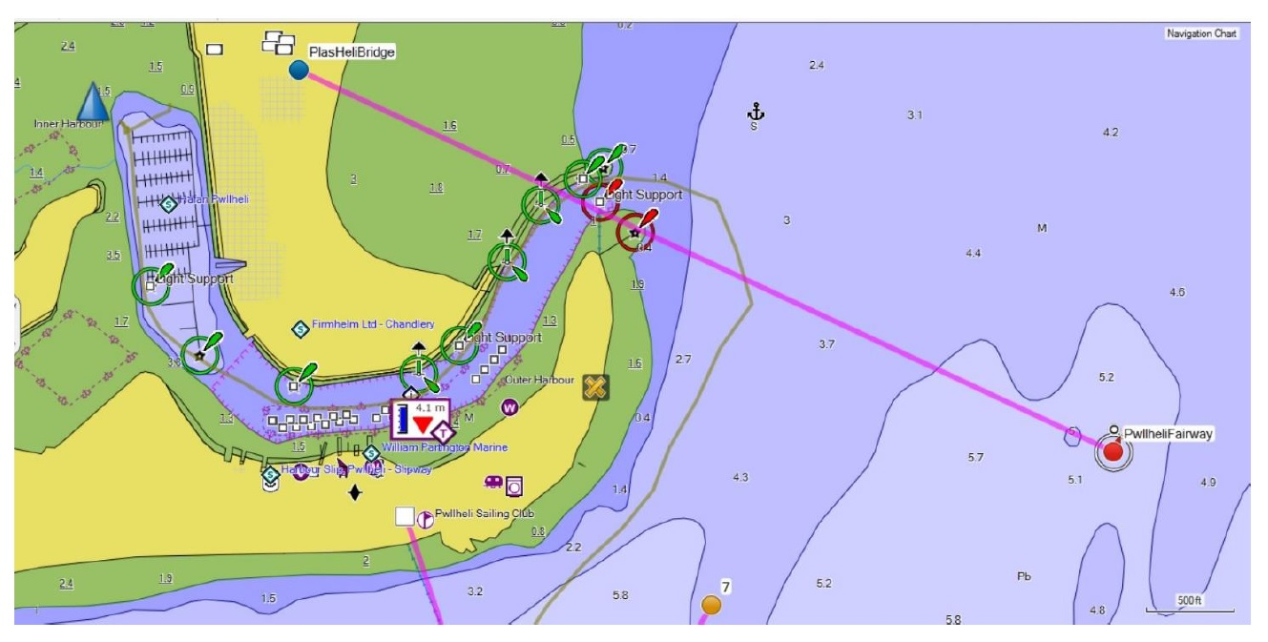

Clwb Hwylio Pwllheli Sailing Club
The 2015 Pwllheli Long Bay Race and ISORA P2P
Racing Entry Form
Owner |  |  |  |  | Yacht
Owner/Skipper name |  |  |  |  | Yacht Name
Address |  |  |  |  | Sail Number
IRC Rating TCC….(No.)
See note below if no valid Cert available
 |  |  |  |  | NHC (base number – this will be provided by the Race Committee)
 |  |  |  |  | Type / Class of Yacht
Postcode |  |  |  |  | Designer
Telephone – Day |  |  |  |  | LOA
Telephone – Evening |  |  |  |  | Colour of hull
Fax No. |  |  |  |  | Club…………………………………………………………….  Non members - please state which RYA Affiliated Club represented
Mobile No,
Please provide e.mail address
Class Entered  Tick box | IRC | NHC |  |  | Enclosed Copy of current Certificate  Tick box |  |  | IRC
Series |  |  | £ | Tick box |  | Certificate/Payment |  |  | Tick box
Saturday CHPSC ISORA P2P |  |  | £15 |  |  | I enclose a copy of my current Rating Certificate
 |  |  |  |  |  | I do not have a valid IRC certificate and I would be obliged if the Race Committee would score the series using NHC (club)
A separate entry is required for the ISORA race see ISORA
Total |  |  | £15  ............ | I enclose £……………………….in entry fees  (cheques payable to Pwllheli Sailing Club)
 |  |  |  | I have paid at the Club Bar with my Club Card Receipt attached
Declaration
Adequate third party insurance is held with respect to this yacht. The yacht is fully equipped with safety equipment in accordance with its class requirement.
I hereby agree to be bound by the Racing Rules of Sailing (RRS) that govern this regatta. I confirm that I have read the Notice of Race and accept its provisions and agree that my boat will conform to the requirements set out in the Notice of Race throughout the event
I herby indemnify Clwb Hwylio Pwllheli Sailing Club and the Sailing Committee against all claims whatsoever arising from my yachts participation in these races.
I agree to allow any photographs taken during the event to be used by CHPSC for promotional purposes.
Signature……………………………………………….… |  |  |  |  |  |  | Date……………………………………………….…….
YACHT THAT HAVE NOT PAID THEIR RACING FEES WILL NOT QUALIFY AS STARTERS
Clwb Hwylio Pwllheli Sailing Club, Glan Y Don, Pwllheli, Gwynedd LL53 5YT
racing@pwllhelisailingclub.co.uk www.pwllhelisailingclub.co.uk
Office 01758 613343 Bar / Clubroom 01758 614442

